Exp No. 6 — Time Series Analysis of Website Traffic
Aim:
To analyze the time series data of website traffic to identify trends, seasonality, and anomalies.
Description:
The website traffic data is loaded and analyzed using time series decomposition. Moving average is used to identify trends, and statistical methods are used to detect anomalies in the website traffic.
Code:
import pandas as pd
import matplotlib.pyplot as plt
from statsmodels.tsa.seasonal import seasonal_decompose

data = pd.read_csv('website_traffic.csv', parse_dates=['Date'], index_col='Date')

decomposition = seasonal_decompose(data['Page_Views'], model='additive')
decomposition.plot()
plt.show()

data['Page_Views_MA'] = data['Page_Views'].rolling(window=20).mean()

data[['Page_Views', 'Page_Views_MA']].plot()
plt.title('Page Views with Moving Average')
plt.show()

data['Page_Views_Z'] = (data['Page_Views'] - data['Page_Views'].mean()) / data['Page_Views'].std()

anomalies = data[data['Page_Views_Z'].abs() > 2.5]

plt.plot(data.index, data['Page_Views'], label='Page Views')
plt.scatter(anomalies.index, anomalies['Page_Views'], color='red', label='Anomalies')
plt.legend()
plt.show()

Output:
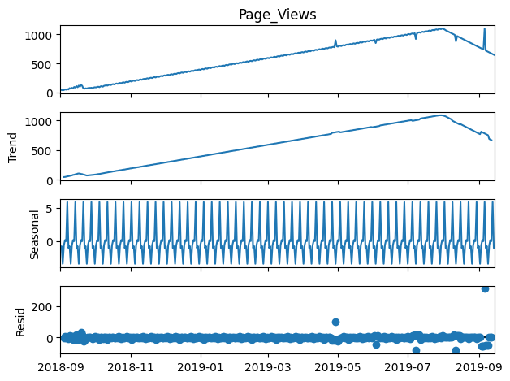
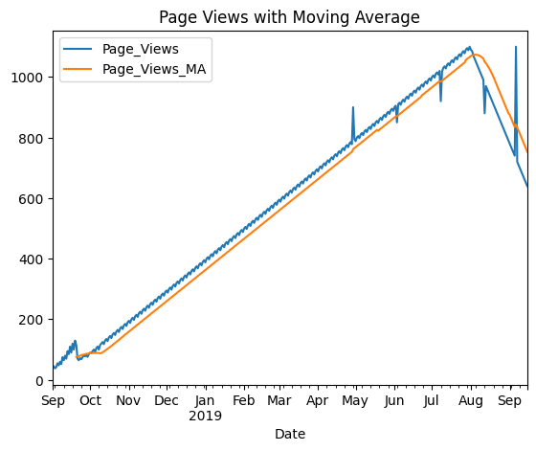
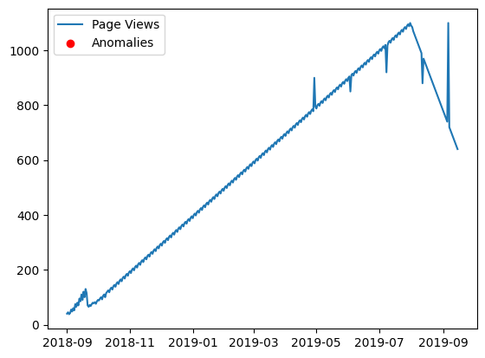
Result:
The website traffic over time is visualized using a line plot, showing the variations and sudden increases in page views.

